https://doi.org/10.XXXX/xxxxx (Edited by the Editorial Office)
Original Scientific Article / Izvorni znanstveni članak (Select article type)

Title

Given Name FAMILY NAME, Given Name FAMILY NAME – City 1
Given Name FAMILY NAME – City 2

ABSTRACT. The optimal abstract length is 250 words.

Keywords: up to five keywords, separated by commas.

Introduction

All sections and subsections in this document are defined by their respective styles. Two blank lines should be inserted before each main section. All fonts, font sizes, spacing, and line spacing are predefined. The main text of the paper should be in Times New Roman, 12 pt (style: 3.1_main_text).

Instructions provided in this template must be deleted before submitting the article to OJS.

Section (level 1)

Two blank lines should precede each main section (Level 1 section). One blank line should precede Level 2 and Level 3 sections. One blank line should follow each section heading, after which the main text begins.

Subsection (level 2)

The mandatory main sections of the article are Introduction and Conclusions. Depending on the subject matter, the article may be structured into additional Level 1 sections (main sections) and Level 2 or Level 3 sections (subsections).

Subsection (level 3)

Equations in the text should be centered (style: 3.5.1_equation), while their numbering (style: 3.5.2_equation_number) should be right-aligned. All expressions must be cited in the text at the appropriate places:
 | $$ΔH=l_{A}-l_{B}$$ | (1)
where:
$ΔH$ – symbol description,
$l_{A}$ – symbol description,
$l_{B}$ – symbol description.

Bulleted lists look like this:
- First bullet,
- Second bullet,
- Third bullet.

Numbered lists can be added as follows:
- First item,
- Second item,
- Third item.

Section (level 1)

Figures in the text should be centered (style: 4.1_figure), and the caption below the figure should also be centered. Attention should be paid to italic formatting in figure captions. All figures must be cited in the text at appropriate places (e.g., Figure 1). Authors must use cross-references when citing figures; manual numbering is not permitted. The resolution of figures, graphs, diagrams, etc., should not be lower than 300 DPI. The dimensions of figures and tables must not exceed the page margins.

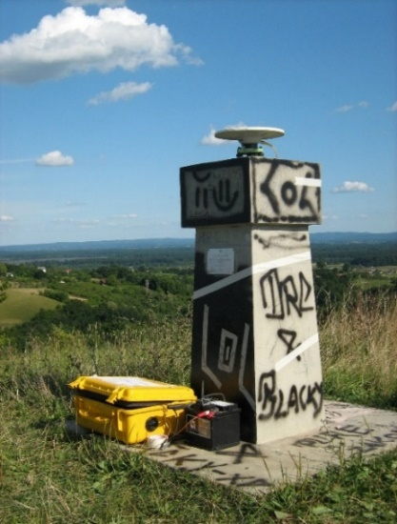
Figure 1. GNSS observations at station Brusnik (Zrinjski 2010).

Tables in the text should be centered, and the caption above the table (styles: 5.2_table_number and 5.2_table_caption) should be aligned with the left edge of the table. The text within tables should be in Times New Roman 11 pt (style: 5.1_table_content). All tables must be cited in the text at appropriate places (e.g., Table 1). Authors must use cross-references when citing tables; manual numbering is not permitted. Attention should be paid to italic formatting in table titles.

A blank line should be inserted between two paragraphs (style: 1.0_empty_line).

Table 1. List of surveying instrument manufacturers.
Manufacturer | Total station
Leica Geosystems | Nova TS60
Trimble | S9
Topcon | PS-101
Sokkia | SX101T

Conclusions

Paragraph.

Paragraph.

References

Each reference listed in the bibliography should, wherever possible, include a DOI (Digital Object Identifier). Authors are required to provide a DOI for all publications for which it exists. The DOI must be given in its full form as a web link (https://doi.org/...).

Special attention should be paid to correct citation of references. The cited literature should be listed in alphabetical order by authors’ surnames.

Articles in the reference list should be formatted as follows: author’s surname, initials of given name (if there are multiple authors, they are separated by commas), year in parentheses, article title, journal name or its international abbreviation (in italics), volume number, issue number, first and last page, DOI.
Example:
Kobryń, A. (2021): Geodetic Network Geometry versus Reliability Measures in Examples of the Trilateration Network, Journal of Surveying Engineering, 147, 3, 1–18. https://doi.org/10.1061/(ASCE)SU.1943-5428.0000360
Books in the reference list should be formatted as follows: author’s surname, initials of given name, year in parentheses, book title, publisher, place of publication.
Example:
Macarol, S. (1950): Praktična geodezija, Tehnička knjiga, Zagreb.
URLs should be cited in the text of the article in their order of appearance: (URL 1), (URL 2), etc. In the reference list at the end of the article, the following should be provided: title, full URL address, and the date of last access to the referenced address.
Example:
URL 1: Croatian Geodetic Society, http://www.hgd1952.hr, (21. 4. 2026.).

Only titles and URLs cited in the text of the article at the appropriate places may be included in the reference list.

Other examples of reference/source formatting:
Zrinjski, M., Barković, Đ., Gabela, J. (2016): Review of the New International Test Standard for GNSS RTK Measurement Systems, International Symposium on Engineering Geodesy, Conference Proceedings, Croatian Geodetic Society, Varaždin, Croatia, 235–244.
Tupek, A. (2024): Development of a GNSS Antenna Calibration System, PhD dissertation, University of Zagreb Faculty of Geodesy, Zagreb, Croatia.
Odziemczyk, W. (2025): Hybrid algorithm for identification of stable reference points in a monitoring network, Journal of Applied Geodesy, 20, 2, 351–364.
https://doi.org/10.1515/jag-2024-0083
Hofmann-Wellenhof, B., Lichtenegger, H., Wasle, E. (2008): GNSS – Global Navigation Satellite Systems, Springer-Verlag Wien, Wien, Austria.

URLs
URL 1: Croatian Geodetic Society,
https://www.hgd1952.hr, (21. 4. 2026.).
URL 2: Geodetski list,
https://ojs.srce.hr/geodetski-list/index, (21. 4. 2026.).

Naslov rada

SAŽETAK. Sažetak rada na hrvatskom jeziku.

Ključne riječi: do pet ključnih riječi odvojenih zarezom.

Received / Primljeno: (Edited by the Editorial Office)
Accepted / Prihvaćeno: (Edited by the Editorial Office)

Title, Given Name Family Name, academic degree, Affiliation, Street and number, City, Country, e-mail: mail@mail.hr,
Title, Given Name Family Name, academic degree, Affiliation, Street and number, City, Country, e-mail: mail@mail.hr.

