Legends of Tables and Figures
Figure 1. The vertical, horizontal and seasonal comparisons of heterotrophic bacteria (HB) counts in the lotic and lentic ecosystems: (a) HB in lentic ecosystem, (b) HB in lotic ecosystem, (c) HB in bottom, (d) HB in middle, (e) HB in surface, (f) HB in sediments

Figure 2. The vertical, horizontal and seasonal comparisons of total coliform bacteria (TCB) counts in the lotic and lentic ecosystems: (a) TCB in lentic ecosystem, (b) TCB in lotic ecosystem, (c) TCB in bottom, (d) TCB in middle, (e) TCB in surface, (f) TCB in sediments

Figure 3. Statistical analyses result on vertical distributions of bacteria in the sampled lotic and lentic ecosystems: (a) Bray-Curtis cluster analysis, (b) Correspondence analysis

Figure 4. Bray-Curtis similarity index results for physicochemical analyses in lentic and lotic ecosystems

Table 1. The seasonal, vertical, and horizontal distributions of bacteria in the lotic and lentic ecosystems (Units are cfu 100⁻¹ mL for HB and MPN 100⁻¹ mL for other bacteria in water columns; cfu 100⁻¹ g for HB and MPN 100⁻¹ g for other bacteria in sediments), (HB: heterotrophic bacteria, TCB: total coliform bacteria, FCB: faecal coliform bacteria, E.coli: Escherichia coli, cfu: colony forming unit, MPN: most probable number)

Table 2. The average values of physico-chemical features in the lotic and lentic ecosystems (b: bottom; m: middle; s: surface water columns; EC: conductivity; DO: dissolved oxygen; Temp:temperature; Ca: kalsiyum; Mg: magnezyum; Cl: chloride)

Table 3. The heavy metal concentrations in the ecosystems (bot: bottom; mid: middle; surf: surface; sho: shore; mud: deep sediment)

(a) (b)

(c) (d)

(e) (f)

Figure 1. The vertical, horizontal and seasonal comparisons of heterotrophic bacteria (HB) counts in the lotic and lentic ecosystems: (a) HB in lentic ecosystem, (b) HB in lotic ecosystem, (c) HB in bottom, (d) HB in middle, (e) HB in surface, (f) HB in sediments

(a) (b)

(c) (d)

(e) (f)

Figure 2. The vertical, horizontal and seasonal comparisons of total coliform bacteria (TCB) counts in the lotic and lentic ecosystems: (a) TCB in lentic ecosystem, (b) TCB in lotic ecosystem, (c) TCB in bottom, (d) TCB in middle, (e) TCB in surface, (f) TCB in sediments

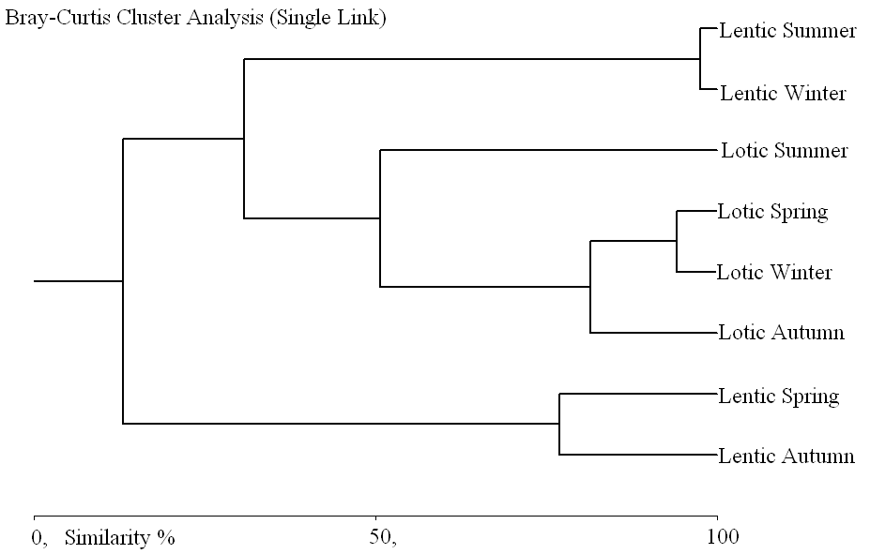

(a)
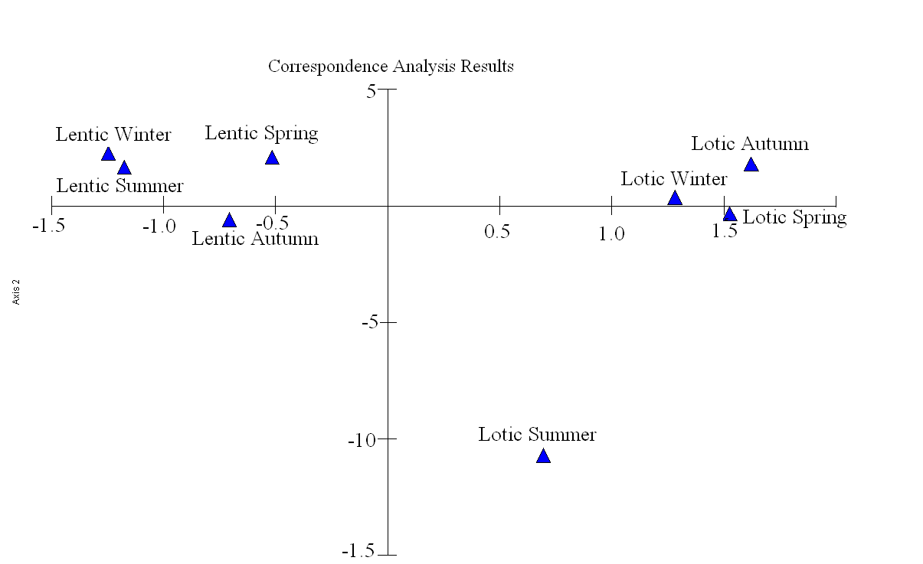
(b)

Figure 3. Statistical analyses result on vertical distributions of bacteria in the sampled lotic and lentic ecosystems: (a) Bray-Curtis cluster analysis, (b) Correspondence analysis

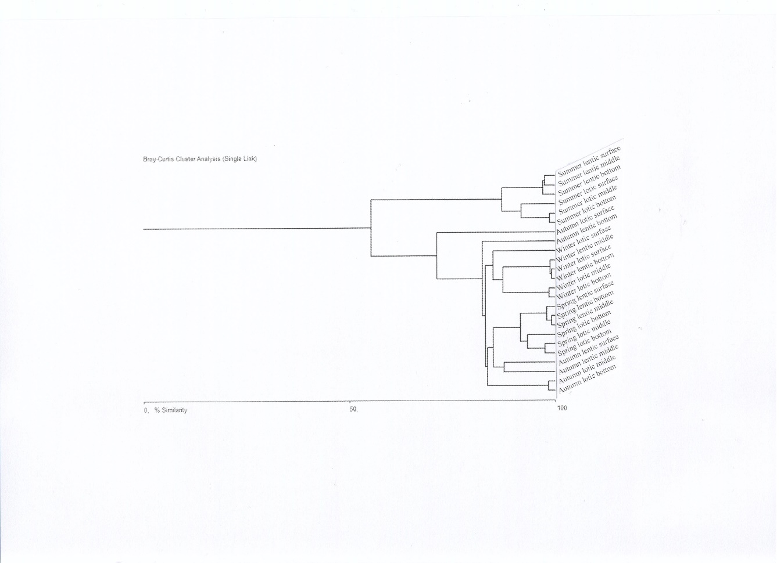

Figure 4. Bray-Curtis similarity index results for physicochemical analyses in lentic and lotic ecosystems

Table 1. The seasonal, vertical, and horizontal distributions of bacteria in the lotic and lentic ecosystems (Units are cfu 100⁻¹ mL for HB and MPN 100⁻¹ mL for other bacteria in water columns; cfu 100⁻¹ g for HB and MPN 100⁻¹ g for other bacteria in sediments), (HB: heterotrophic bacteria, TCB: total coliform bacteria, FCB: faecal coliform bacteria, E.coli: Escherichia coli, cfu: colony forming unit, MPN: most probable number)

Autumn |  |  |  |  |  |  | Winter
 |  | HB |  | TCB | FCB | E.coli |  | HB | TCB | FCB | E.coli
Lotic | Bot | 1.1X10⁶ |  | 3.8X10² | 2.8X10² | 2.8X10² |  | 1.9x10⁶ | 1.7x10³ | 1.3x10³ | 1.1x10³
Lotic | Mid | 1.0X10⁶ |  | 3.5X10² | 3.4X10¹ | 3.4X10¹ |  | 1.7x10⁶ | 1.6x10³ | 3.0x10² | 2.2x10²
Lotic | Surf | 1.2X10⁶ |  | 9.0X10¹ | 9.0X10¹ | 9.0X10¹ |  | 1.8x10⁶ | 1.1x10³ | 8.0x10² | 5.0x10²
Lotic | Sho | 1.7X10⁸ |  | >1.6X10⁴ | 1.6X10⁴ | 1.6X10⁴ |  | 1.9x10⁸ | 9.0x10³ | 7.0x10² | 4.0x10²
Lotic | Mud | 9.0X10⁷ |  | 3.2X10² | 2.6X10² | 2.2X10² |  | 1.8x10⁸ | 5.0x10³ | 5.0x10² | 3.4x10²
Lentic | Bot | 7.0X10³ |  | 8.0X10⁰ | 8.0X10⁰ | 2.0X10⁰ |  | 2.0x10⁵ | 8.0x10⁰ | 2.0x10⁰ | 2.0x10¹
Lentic | Mid | 2.0X10³ |  | 7.0X10⁰ | 4.0X10⁰ | 2.0X10⁰ |  | 1.0x10⁵ | 1.1x10¹ | <2.0x10⁰ | <2.0x10¹
Lentic | Surf | 1.6X10⁴ |  | 4.0X10⁰ | 4.0X10⁰ | 4.0X10⁰ |  | 3.0x10⁵ | 1.7x10¹ | <2.0x10⁰ | <2.0x10¹
Lentic | Sho | 1.0X10⁷ |  | 2.0x10¹ | 2.0x10¹ | 2.0x10¹ |  | 3.0x10⁶ | <2.0x10¹ | <2.0x10¹ | <2.0x10¹
Lentic | Mud | 3.2X10⁷ |  | 2.2X10² | 2.2X10² | 2.2X10² |  | 9.0x10⁷ | <2.0x10¹ | <2.0x10¹ | <2.0x10¹
Spring |  |  |  |  |  |  | Summer
 |  | HB |  | TCB | FCB | E.coli |  | HB | TCB | FCB | E.coli
Lotic | Bot | 1.0x10⁶ |  | 1.7x10³ | 1.3x10³ | 8.0x10² |  | 5.0x10⁶ | 2.2x10³ | 2.8x10² | 1.3x10²
Lotic | Mid | 1.0x10⁶ |  | 1.3x10³ | 3.3x10² | 2.2x10² |  | 2.1x10⁶ | 1.7x10³ | 1.7x10² | 8.0x10¹
Lotic | Surf | 3.0x10⁶ |  | 1.4x10³ | 9.0x10² | 5.0x10² |  | 9.0x10⁶ | 3.5x10³ | 3.4x10² | 2.7x10²
Lotic | Sho | 5.8x10⁹ |  | 7.0x10³ | 3.5x10³ | 1.4x10³ |  | 1.2x10⁷ | 2.2x10³ | 1.3x10³ | 8.0x10²
Lotic | Mud | 2.0x10⁹ |  | 5.0x10³ | 2.2x10³ | 1.1x10³ |  | 1.0x10⁷ | 2.1x10³ | 7.0x10² | 5.0x10²
Lentic | Bot | 1.0x10⁴ | 1.4x10¹ |  | 2.0x10⁰ | 2.0x10⁰ |  | 1.4x10⁵ | 2.0x10¹ | <2.0x10¹ | <2.0x10¹
Lentic | Mid | 1.0x10⁴ | 1.7x10¹ |  | <2.0x10⁰ | <2.0x10⁰ |  | 7.0x10⁴ | 2.0x10¹ | <2.0x10¹ | <2.0x10¹
Lentic | Surf | 2.0x10⁴ | 4.0x10¹ |  | <2.0x10⁰ | <2.0x10⁰ |  | 3.6x10⁵ | 4.0x10¹ | <2.0x10¹ | <2.0x10¹
Lentic | Sho | 1.2x10⁷ | 4.0x10¹ |  | <2.0x10¹ | <2.0x10¹ |  | 1.8x10⁷ | 5.0x10³ | 2.0x10¹ | 2.0x10¹
Lentic | Mud | 3.1x10⁷ | 1.1x10² |  | <2.0x10¹ | <2.0x10¹ |  | 3.2x10⁷ | 5.0x10³ | 1.1x10³ | 9.0x10²

Table 2. The average values of physico-chemical features in the lotic and lentic ecosystems (b: bottom; m: middle; s: surface water columns; EC: conductivity; DO: dissolved oxygen; Temp:temperature; Ca: kalsiyum; Mg: magnezyum; Cl: chloride)

Season | Autumn |  |  |  |  |  | Winter |  |  |  |  |  | Spring |  |  |  |  |  | Summer
ecosysystem | Lotic |  |  | Lentic |  |  | Lotic |  |  | Lentic |  |  | Lotic |  |  | Lentic |  |  | Lotic |  |  | Lentic
column  parameters↓ | b | m | s | b | m | s | b | m | s | b | m | s | b | m | s | b | m | s | b | m | s | b | m | s
EC (mS cm⁻¹) | 0,3 | 0,3 | 0,3 | 0,3 | 0,3 | 0,3 | 0,3 | 0,3 | 0,3 | 0,2 | 0,2 | 0,2 | 0,6 | 0,6 | 0,6 | 0,2 | 0,2 | 0,2 | 0,6 | 0,6 | 0,6 | 0,2 | 0,3 | 0,3
pH | 7,8 | 7,8 | 7,8 | 8,5 | 8,5 | 8,4 | 7,8 | 7,8 | 7,8 | 7,8 | 7,7 | 8,4 | 7,6 | 7,3 | 7,4 | 9,1 | 8,9 | 9,0 | 8,4 | 8,4 | 8,4 | 9,2 | 9,2 | 9,1
DO (mg L⁻¹) | 8,9 | 8,8 | 8,3 | 7,8 | 7,7 | 7,7 | 8,9 | 8,7 | 8,4 | 8,3 | 8,6 | 8,4 | 11,9 | 11,6 | 12,0 | 17,9 | 17,8 | 17,6 | 5,8 | 5,9 | 5,9 | 6,9 | 6,8 | 6,5
Temp. (⁰C) | 9,0 | 10 | 10 | 17 | 17 | 18 | 4,0 | 4,0 | 5,0 | 5,0 | 5,0 | 5,0 | 19,0 | 20,0 | 19,0 | 18,0 | 19,0 | 19,0 | 21 | 22 | 23 | 24 | 24 | 25
Salinity (‰) | 0,1 | 0,1 | 0,1 | 0,1 | 0,1 | 0,1 | 0,3 | 0,3 | 0,3 | 0,1 | 0,1 | 0,1 | 0,16 | 0,16 | 0,16 | 0,1 | 0,1 | 0,1 | 0,3 | 0,3 | 0,3 | 0,1 | 0,1 | 0,1
Ca (mg L⁻¹) | 4,6 | 4,6 | 4,6 | 2,6 | 3,4 | 4,2 | 4,4 | 4,5 | 4,6 | 0,7 | 0,7 | 0,5 | 4,8 | 4,4 | 5,2 | 8,0 | 8,4 | 9,5 | 172 | 169 | 173 | 77 | 82 | 84
Mg (mg L⁻¹) | 11 | 11 | 14 | 73 | 11 | 33 | 1,0 | 1,0 | 1,1 | 1,0 | 1,0 | 0,9 | 1,8 | 1,7 | 1,7 | 0,9 | 0,9 | 0,8 | 225 | 219 | 214 | 225 | 217 | 206
NO₂N (mg L⁻¹) | 0,08 | 0,09 | 0,16 | 0,15 | 0,15 | 0,15 | 0,08 | 0,09 | 0,14 | 0,05 | 0,05 | 0,04 | 0,09 | 0,09 | 0,10 | 0,11 | 0,11 | 0,15 | 0,08 | 0,09 | 0,15 | 0,17 | 0,17 | 0,17
NO₃N (mg L⁻¹) | 4,8 | 4,7 | 3,2 | 0,8 | 0,7 | 0,8 | 13 | 13 | 12 | 6,2 | 6,3 | 6,1 | 4,2 | 4,2 | 4,5 | 3,2 | 3,2 | 3,5 | 4,8 | 4,7 | 3,2 | 3,1 | 3,0 | 2,8
PO₄ (mg L⁻¹) | 0,6 | 0,6 | 1,0 | 0,9 | 0,9 | 0,9 | 0,4 | 0,4 | 0,5 | 0,3 | 0,3 | 0,3 | 0,5 | 0,5 | 0,6 | 0,4 | 0,4 | 0,5 | 0,6 | 0,6 | 1,0 | 0,5 | 0,5 | 0,5
SO₄ (mg L⁻¹) | 38 | 40 | 57 | 22 | 24 | 24 | 28 | 30 | 47 | 21 | 22 | 21 | 22 | 20 | 25 | 23 | 23 | 24 | 38 | 40 | 57 | 24 | 24 | 21
Cl (mg L⁻¹) | 13 | 13 | 70 | 14 | 14 | 15 | 12 | 12 | 21 | 12 | 12 | 12 | 12 | 12 | 20 | 13 | 13 | 14 | 13 | 13 | 70 | 22 | 13 | 12

Table 3. The heavy metal concentrations in the ecosystems (bot: bottom; mid: middle; surf: surface; sho: shore; mud: deep sediment)

 |  |  | Na | Al | Cr | Mn | Fe | Co | Ni | Cu | Zn | As | Se | Cd | Pb
Autumn | Lotic | bot* | 0.02 | 0.00 | 0.01 | 0.05 | 1.759 | 0.00 | 0.04 | 0.04 | 0.09 | 0.00 | 0.02 | 0.00 | 0.05
Autumn | Lotic | mid* | 0.02 | 0.04 | 0.01 | 0.07 | 3.500 | 0.00 | 0.06 | 0.04 | 0.1 | 0.00 | 0.02 | 0.00 | 0.05
Autumn | Lotic | surf* | 0.05 | 0.03 | 0.01 | 0.06 | 2.903 | 0.00 | 0.04 | 0.03 | 0.07 | 0.00 | 0.02 | 0.00 | 0.05
Autumn | Lotic | sho** | 0.14 | 6.41 | 21.8 | 212 | 6547 | 2.97 | 27.2 | 11.2 | 77 | 4.26 | 0.73 | 0.93 | 24.8
Autumn | Lotic | mud** | 0.28 | 10.0 | 22.5 | 491 | 11638 | 5.10 | 14.4 | 20.1 | 153 | 12.1 | 1.37 | 0.24 | 65.2
Autumn | Lentic | bot* | 0.59 | 0.00 | 0.01 | 0.01 | 0.095 | 0.00 | 0.04 | 0.02 | 0.09 | 0.01 | 0.02 | 0.00 | 0.04
Autumn | Lentic | mid* | 0.02 | 0.00 | 0.01 | 0.02 | 0.095 | 0.00 | 0.03 | 0.02 | 0.09 | 0.00 | 0.02 | 0.00 | 0.04
Autumn | Lentic | surf* | 0.08 | 0.00 | 0.01 | 0.02 | 0.096 | 0.00 | 0.05 | 0.02 | 0.1 | 0.00 | 0.02 | 0.00 | 0.05
Autumn | Lentic | sho** | 0.03 | 4.37 | 2.75 | 81.4 | 5163 | 1.62 | 4.80 | 0.71 | 23 | 0.82 | 0.86 | 0.01 | 3.48
Autumn | Lentic | mud** | 0.04 | 5.56 | 4.67 | 116 | 6255 | 1.98 | 0.36 | 1.50 | 19 | 1.01 | 0.75 | 0.02 | 4.33
Winter | Lotic | bot* | 0.02 | 0.00 | 0.01 | 0.02 | 0.26 | 0.00 | 0.05 | 0.02 | 0.09 | 0.00 | 0.01 | 0.00 | 0.05
Winter | Lotic | mid* | 0.02 | 0.00 | 0.01 | 0.02 | 0.26 | 0.00 | 0.05 | 0.02 | 0.09 | 0.00 | 0.01 | 0.00 | 0.05
Winter | Lotic | surf* | 0.02 | 0.00 | 0.01 | 0.02 | 0.24 | 0.00 | 0.05 | 0.02 | 0.09 | 0.00 | 0.01 | 0.00 | 0.05
Winter | Lotic | sho** | 0.06 | 1.05 | 2.25 | 291 | 1638 | 0.51 | 2.34 | 2.31 | 83.1 | 0.45 | 0.67 | 0.24 | 4.21
Winter | Lotic | mud** | 0.07 | 1.03 | 2.51 | 280 | 1508 | 0.69 | 2.33 | 2.38 | 83.9 | 0.48 | 0.69 | 0.29 | 4.83
Winter | Lentic | bot* | 0.00 | 0.00 | 0.01 | 0.01 | 0.38 | 0.00 | 0.01 | 0.03 | 0.12 | 0.00 | 0.01 | 0.00 | 0.06
Winter | Lentic | mid* | 0.00 | 0.00 | 0.01 | 0.01 | 0.38 | 0.00 | 0.01 | 0.03 | 0.11 | 0.00 | 0.01 | 0.00 | 0.06
Winter | Lentic | surf* | 0.00 | 0.00 | 0.01 | 0.01 | 0.40 | 0.00 | 0.01 | 0.03 | 0.11 | 0.00 | 0.01 | 0.00 | 0.06
Winter | Lentic | sho** | 0.04 | 0.09 | 0.97 | 2.82 | 40.4 | 0.55 | 2.82 | 3.40 | 11.4 | 0.45 | 1.95 | 0.60 | 6.54
Winter | Lentic | mud** | 0.04 | 0.09 | 0.97 | 2.82 | 40.4 | 0.55 | 2.82 | 3.40 | 11.4 | 0.45 | 1.95 | 0.60 | 6.54
Spring | Lotic | bot* | 0.00 | 0.00 | 0.01 | 0.01 | 2.14 | 0.00 | 0.02 | 0.04 | 0.06 | 0.00 | 0.51 | 0.00 | 0.06
Spring | Lotic | mid* | 0.00 | 0.00 | 0.01 | 0.01 | 2.09 | 0.00 | 0.02 | 0.05 | 0.07 | 0.00 | 0.49 | 0.00 | 0.09
Spring | Lotic | surf* | 0.00 | 0.00 | 0.01 | 0.00 | 2.08 | 0.00 | 0.02 | 0.04 | 0.07 | 0.00 | 0.49 | 0.00 | 0.05
Spring | Lotic | sho** | 0.19 | 11.3 | 21.8 | 427 | 8206 | 4.55 | 10.8 | 28.9 | 95.9 | 5.71 | 1.34 | 1.34 | 34.9
Spring | Lotic | mud** | 0.18 | 12.1 | 25.5 | 307 | 9078 | 4.10 | 10.1 | 25.4 | 100 | 5.65 | 1.45 | 1.45 | 33.0
Spring | Lentic | bot* | 0.00 | 0.00 | 0.01 | 0.02 | 1.28 | 0.00 | 0.01 | 0.03 | 0.05 | 0.00 | 0.12 | 0.00 | 0.05
Spring | Lentic | mid* | 0.00 | 0.00 | 0.01 | 0.02 | 1.27 | 0.00 | 0.01 | 0.03 | 0.07 | 0.00 | 0.11 | 0.00 | 0.05
Spring | Lentic | Surf* | 0.00 | 0.00 | 0.01 | 0.02 | 1.20 | 0.01 | 0.02 | 0.08 | 0.06 | 0.00 | 0.04 | 0.00 | 0.05
Spring | Lentic | sho** | 0.02 | 0.34 | 0.38 | 6.03 | 333 | 0.11 | 1.92 | 0.56 | 4.69 | 5.23 | 0.04 | 0.04 | 0.85
Spring | Lentic | mud** | 0.02 | 0.25 | 0.33 | 4.15 | 199 | 0.17 | 0.61 | 0.46 | 1.43 | 5.69 | 0.01 | 0.04 | 0.75
Summer | Lotic | bot* | 0.44 | 0.00 | 0.26 | 1.52 | 18.4 | 0.02 | 0.27 | 0.45 | 1.25 | 0.08 | 2.30 | 0.00 | 0.10
Summer | Lotic | mid* | 0.42 | 0.00 | 0.24 | 0.80 | 16.9 | 0.02 | 0.25 | 0.49 | 0.75 | 0.07 | 2.10 | 0.00 | 0.05
Summer | Lotic | surf* | 0.47 | 0.00 | 0.24 | 0.81 | 15.7 | 0.02 | 0.17 | 0.12 | 0.31 | 0.08 | 1.93 | 0.00 | 0.06
Summer | Lotic | sho** | 0.10 | 3.03 | 5.17 | 122 | 164 | 1.72 | 4.31 | 3.05 | 31.4 | 1.61 | 1.29 | 0.01 | 8.23
Summer | Lotic | mud** | 0.28 | 16.3 | 37.4 | 279 | 260 | 6.93 | 15.9 | 117 | 254 | 33.3 | 4.08 | 0.12 | 149
Summer | Lentic | bot* | 0.25 | 0.00 | 0.34 | 0.53 | 31.0 | 0.02 | 1.02 | 0.43 | 0.38 | 0.04 | 3.22 | 0.00 | 0.03
Summer | Lentic | mid* | 0.33 | 0.00 | 0.35 | 0.59 | 30.2 | 0.02 | 0.54 | 0.37 | 0.39 | 0.05 | 3.11 | 0.00 | 0.04
Summer | Lentic | surf* | 0.23 | 0.00 | 0.36 | 0.60 | 28.9 | 0.04 | 1.83 | 0.10 | 0.27 | 0.08 | 3.02 | 0.02 | 0.16
Summer | Lentic | sho** | 0.05 | 0.27 | 2.99 | 73.3 | 271 | 1.78 | 1.98 | 1.39 | 11.2 | 0.62 | 2.66 | 0.00 | 1.94
Summer | Lentic | mud** | 0.07 | 0.47 | 6.83 | 130 | 177 | 2.51 | 3.60 | 2.48 | 22.0 | 1.07 | 3.49 | 0.00 | 3.02
* μg mL⁻¹; **μg g⁻¹

