Dr.sc. Igor Mikloušić
Post-doctoral researcher
INSTITUT DRUŠTVENIH ZNANOSTI IVO PILAR
Marulićev trg 19/1
igor.miklousic@pilar.hr

Zagreb, 30.10.2017

Dear Sir or Madam

I am writing to submit the paper titled «Stone-age strategies and space-age media: Sex differences in sexual signaling on Facebook» to the Periodicum Biologorum journal.
The manuscript has not been submitted for publication or published elsewhere, all authors concur with the submission, and the survey has no conflicting ethical issues or conflicts-of-interest.

Accompanying this letter, you will find the original manuscript, literature list and document containing the tables that are found in the paper.

I would like to suggest three possible reviewers;
Prof. dr.sc. Damijan Franjević, Faculty of Science, University of Zagreb (damjan.franjevic@biol.pmf.hr )
Prof. dr.sc. Boris Mlačić, Institute of Social Sciences Ivo Pilar (boris.mlacic@pilar.hr)
Prof. dr.sc. Goran Milas, Institute of Social Sciences Ivo Pilar (goran.milas@pilar.hr )

Sincirely,
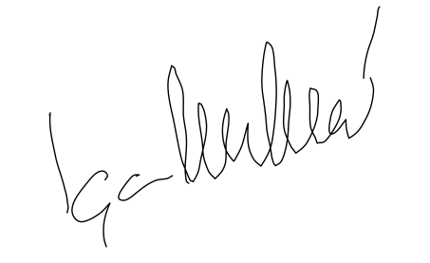
Igor Mikloušić
Igor.miklousic@pilar.hr

