**Middle-late miocene tidal-related deposits of the binio formation: the sedimentary and stratigraphic records during inversion of the Central Sumatra Basin, Indonesia**

**Aurio Erdi1,4, Afrizon Setiawan2, Ismail Zulmi2, Alan Rene Inabuy2, Rifati Hanifa Az Zahra2, Eric Edwin2, Ivan Praja Andhika3, Dany Auliansyah3, Edward Wijaya4**

1Research Centre for Geological Resources, National Research and Innovation Agency (BRIN), Indonesia

2Energi Mega Persada Bentu Limited (EMP Bentu Ltd)

3Rock Flow Dynamics

4PT Kejora Gas Bumi Mandiri

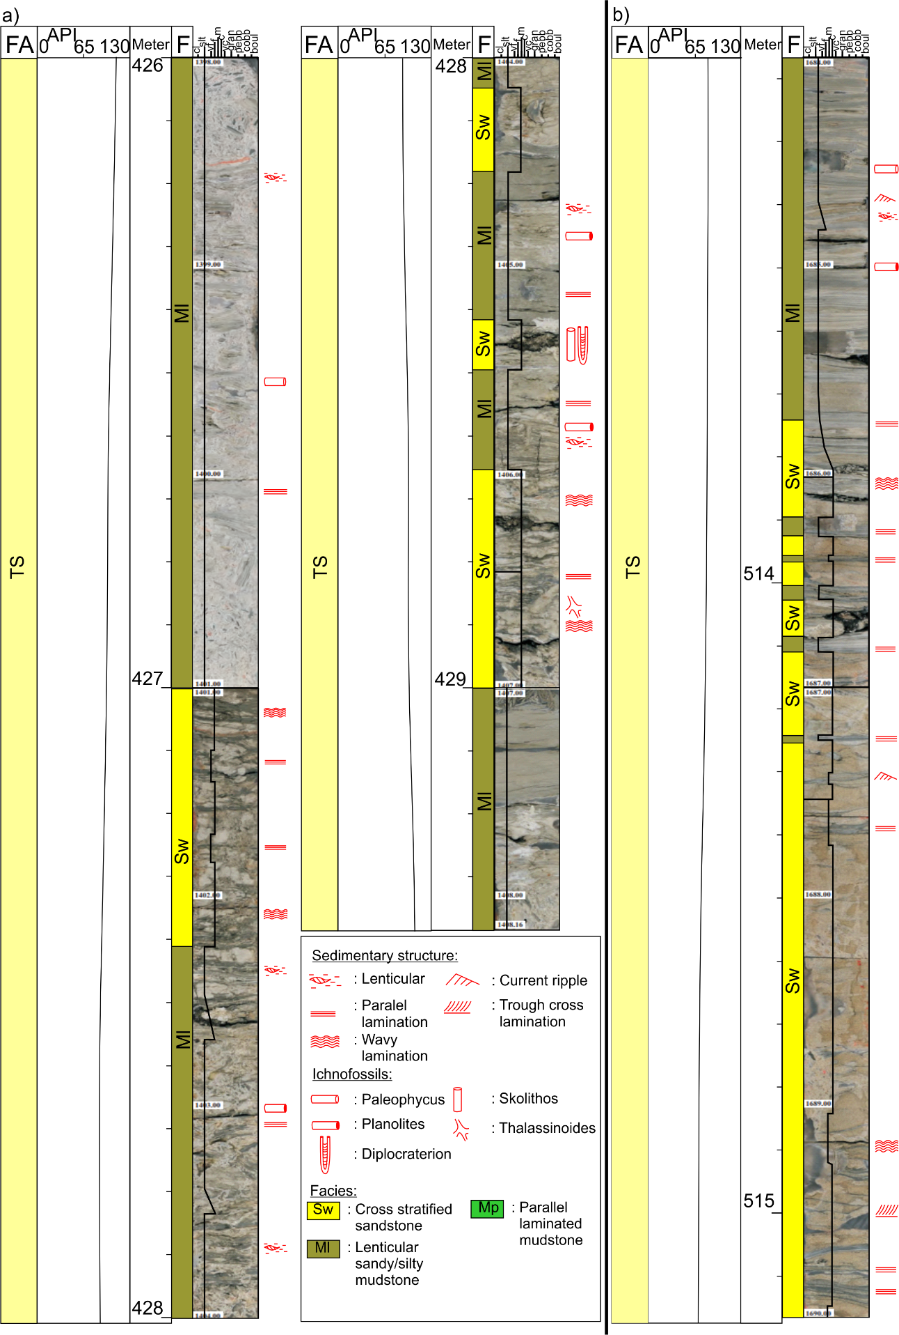

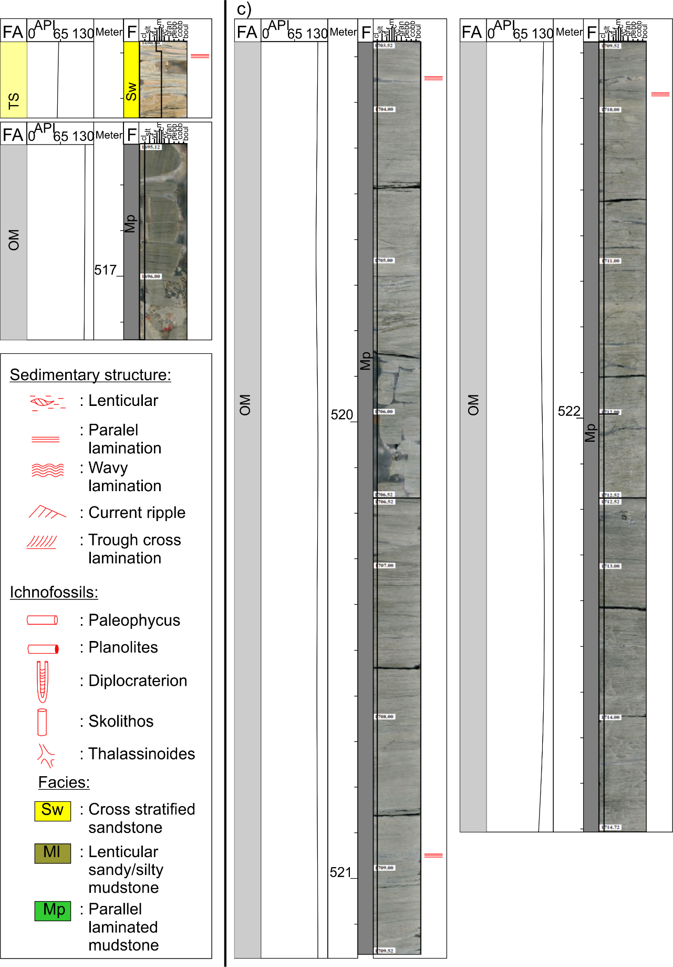

**Figure S1:** A larger versionof **Figure 3** in the main text**.** A chart illustrating the conventional core description and photographs, along with GR log characteristics in well A3 (see the location of A3 in **Figure 1c** in the main text; also see supplementary materials for a larger version of the chart). The facies (F) and facies associations (FA) of the Binio Formation are illustrated, consisting of tidal sand bodies (TS) and open marine (OM) facies (see Table 1 for descriptions). The GR log is presented using the common radioactive unit of the American Petroleum Institute (API).