**Thermal degradation of diverse rock suites: Insights from fractures and physical and mechanical analysis**

**Abid Nawaz**1* [](https://orcid.org/0009-0004-2472-9784)[](mailto:abidgeo88@uop.edu.pk)**, Muhammad Sajid**2,3 [](https://orcid.org/0000-0002-3499-9591)[](mailto:mr.sajid@uop.edu.pk), **Waqas Ahmed**1 [](https://orcid.org/0000-0003-0366-7559)[](mailto:waqas.nce@uop.edu.pk), **Abdul Rahim Asif**1,4 [](https://orcid.org/0000-0002-1938-0977)[](mailto:abdulrahimasif@uop.edu.pk)

1 National Centre of Excellence in Geology, University of Peshawar, Peshawar 25120, Pakistan.

2 Department of Geology, University of Peshawar, Peshawar, 25120, Pakistan.

3 Helmholtz-Zentrum Potsdam, Deutsches GeoForschungsZentrum (GFZ), Telegrafenberg, Potsdam, Germany.

4 Department. of Geology, Fata University, FR Kohat 26100, Pakistan.

**Supplementary file**

**Table 1.** Uniaxial Compressive Strength (UCS), Point Load, Ultrasonic Pulse Velocity (UPV), and Fracture Distribution Results for Rocks

|  |  |  |  |  |  |  |
| --- | --- | --- | --- | --- | --- | --- |
| Rock Types | Temperature Ranges (°C) | | | | | |
| 25 | 150 | 300 | 600 | 800 | 1000 |
| UCS (MPa) | | | | | | |
| SST | 47 | 37 | 32 | 12 | 5 | -- |
| LST | 56 | 46 | 43 | 16 | -- | -- |
| HGN | 71 | 60 | 58 | 26 | 16 | 8 |
| RY | 86 | 74 | 73 | 35 | 22 | 11 |
| QZ | 102 | 90 | 80 | 47 | 29 | 16 |
| DL | 115 | 104 | 103 | 58 | 36 | 21 |
| GN | 128 | 119 | 117 | 75 | 44 | 26 |
| AM | 135 | 128 | 125 | 87 | 51 | 31 |
| GG | 141 | 136 | 133 | 98 | 58 | 37 |
| POINT LOAD INDEX | | | | | | |
| SST | 25 | 21 | 16 | 6 | 3 | ------ |
| LST | 31 | 27 | 22 | 8 | -- | -- |
| HGN | 38 | 34 | 29 | 18 | 9 | 4 |
| RY | 42 | 38 | 34 | 23 | 12 | 6 |
| QZ | 47 | 43 | 40 | 28 | 15 | 9 |
| DL | 52 | 48 | 45 | 32 | 18 | 13 |
| GN | 57 | 54 | 51 | 38 | 23 | 16 |
| AM | 61 | 58 | 55 | 43 | 29 | 20 |
| GG | 68 | 66 | 62 | 52 | 37 | 25 |
| UPV (m/sec) | | | | | | |
| SST | 3256 | 2881 | 2470 | 1176 | 981 | -- |
| LST | 3537 | 3157 | 2709 | 1792 | -- | -- |
| HGN | 4206 | 3808 | 3351 | 2216 | 1508 | 636 |
| RY | 4531 | 4124 | 3712 | 2473 | 1893 | 833 |
| QZ | 4900 | 4505 | 4152 | 2870 | 2154 | 1025 |
| DL | 5120 | 4743 | 4422 | 3156 | 2432 | 1195 |
| GN | 5280 | 4929 | 4698 | 3573 | 2776 | 1698 |
| AM | 5458 | 5165 | 4942 | 3914 | 3160 | 2209 |
| GG | 5741 | 5525 | 5318 | 4518 | 3487 | 2606 |
| FRACTURE DENSITY | | | | | | |
| SST | -- | 0.75 | 1.58 | 3.52 | 4.13 | 6 |
| LST | -- | 0.73 | 1.5 | 2.51 | -- | -- |
| HGN | -- | 0.72 | 1.26 | 2.46 | 3.62 | 5.24 |
| RY | -- | 0.67 | 1.15 | 2.38 | 3.05 | -- |
| QZ | -- | 0.58 | 1.12 | 2.17 | 3.01 | 4.26 |
| DL | -- | 0.54 | 1.07 | 2.01 | 2.71 | 4.22 |
| GN | -- | 0.5 | 1.06 | 1.77 | 2.25 | 3.46 |
| AM | -- | 0.34 | 1.03 | 1.74 | 2.02 | 3.29 |
| GG | -- | 0.33 | 1.02 | 1.36 | 1.92 | 2.51 |

**Table 2.** Results of Porosity, Water Absorption and Specific Gravity of studied rocks

|  |  |  |  |  |  |  |
| --- | --- | --- | --- | --- | --- | --- |
| ROCK TYPES | Temperature Ranges (°C) | | | | | |
| 25 | 150 | 300 | 600 | 800 | 1000 |
| POROSITY (%) | | | | | | |
| SST | 2.60 | 2.92 | 3.04 | 8.98 | 13.31 | -- |
| LST | 2.01 | 2.18 | 2.28 | 6.01 | -- | -- |
| HGN | 1.68 | 1.77 | 1.85 | 3.48 | 4.88 | 6.74 |
| RY | 1.17 | 1.23 | 1.28 | 1.81 | 2.42 | 3.28 |
| QZ | 0.97 | 1.01 | 1.05 | 1.38 | 1.74 | 2.39 |
| DL | 0.61 | 0.63 | 0.66 | 0.83 | 0.96 | 1.26 |
| GN | 0.56 | 0.58 | 0.6 | 0.72 | 0.80 | 1.10 |
| AM | 0.37 | 0.38 | 0.39 | 0.46 | 0.50 | 0.63 |
| GG | 0.30 | 0.31 | 0.31 | 0.36 | 0.39 | 0.48 |
| WATER ABSORPTION (%) | | | | | | |
| SST | 1.67 | 1.87 | 2.02 | 5.79 | 8.85 | -- |
| LST | 1.29 | 1.41 | 1.51 | 3.95 | -- | -- |
| HGN | 0.51 | 0.55 | 0.57 | 0.92 | 1.15 | 1.82 |
| RY | 0.43 | 0.46 | 0.47 | 0.70 | 0.83 | 1.22 |
| QZ | 0.36 | 0.38 | 0.39 | 0.50 | 0.61 | 0.85 |
| DL | 0.21 | 0.218 | 0.23 | 0.28 | 0.32 | 0.43 |
| GN | 0.19 | 0.195 | 0.20 | 0.25 | 0.27 | 0.37 |
| AM | 0.14 | 0.143 | 0.15 | 0.17 | 0.19 | 0.24 |
| GG | 0.11 | 0.112 | 0.12 | 0.13 | 0.14 | 0.17 |
| SPECIFIC GRAVITY (gm/cc) | | | | | | |
| LST | 2.69 | 2.66 | 2.63 | 2.48 | -- | -- |
| HGN | 2.75 | 2.72 | 2.70 | 2.52 | 2.39 | 1.98 |
| RY | 2.80 | 2.78 | 2.75 | 2.60 | 2.47 | 2.12 |
| QZ | 2.86 | 2.84 | 2.82 | 2.67 | 2.57 | 2.21 |
| DL | 3.01 | 2.99 | 2.97 | 2.84 | 2.73 | 2.35 |
| GN | 3.09 | 3.07 | 3.06 | 2.93 | 2.82 | 2.47 |
| AM | 3.14 | 3.13 | 3.11 | 2.99 | 2.89 | 2.59 |
| GG | 3.21 | 3.20 | 3.19 | 3.07 | 2.98 | 2.70 |

**Table 3.** Thermal Damage (DT) Values Calculated Using Uniaxial Compressive Strength (UCS), Ultrasonic Pulse Velocity (UPV), and Point Load (PL) Results

|  |  |  |  |  |  |
| --- | --- | --- | --- | --- | --- |
| Rock Types | Temperature Ranges (°C) | | | | |
| 150 | 300 | 600 | 800 | 1000 |
| DT (UCS) | | | | | |
| DL | 0.07 | 0.14 | 0.38 | 0.53 | 0.77 |
| RY | 0.09 | 0.18 | 0.45 | 0.58 | 0.82 |
| GN | 0.07 | 0.11 | 0.32 | 0.47 | 0.68 |
| SST | 0.12 | 0.24 | 0.64 | 0.70 |  |
| LST | 0.11 | 0.23 | 0.49 |  |  |
| QZ | 0.08 | 0.15 | 0.41 | 0.56 | 0.79 |
| HGN | 0.09 | 0.20 | 0.47 | 0.64 | 0.85 |
| AM | 0.05 | 0.09 | 0.28 | 0.42 | 0.60 |
| GG | 0.04 | 0.07 | 0.21 | 0.39 | 0.55 |
| DT (PL) | | | | | |
| DL | 0.08 | 0.13 | 0.38 | 0.65 | 0.75 |
| RY | 0.10 | 0.19 | 0.45 | 0.71 | 0.86 |
| GN | 0.05 | 0.11 | 0.33 | 0.60 | 0.72 |
| SST | 0.16 | 0.36 | 0.76 | 0.88 |  |
| LST | 0.13 | 0.29 | 0.74 |  |  |
| QZ | 0.09 | 0.15 | 0.40 | 0.68 | 0.81 |
| HGN | 0.11 | 0.24 | 0.53 | 0.76 | 0.89 |
| AM | 0.05 | 0.10 | 0.30 | 0.52 | 0.67 |
| GG | 0.03 | 0.09 | 0.24 | 0.46 | 0.63 |
| DT (UPV) | | | | | |
| DL | 0.07 | 0.14 | 0.38 | 0.53 | 0.77 |
| RY | 0.09 | 0.18 | 0.45 | 0.58 | 0.82 |
| GN | 0.07 | 0.11 | 0.32 | 0.47 | 0.68 |
| SST | 0.12 | 0.24 | 0.64 | 0.70 |  |
| LST | 0.11 | 0.23 | 0.49 |  |  |
| QZ | 0.08 | 0.15 | 0.41 | 0.56 | 0.79 |
| HGN | 0.09 | 0.20 | 0.47 | 0.64 | 0.85 |
| AM | 0.05 | 0.09 | 0.28 | 0.42 | 0.60 |
| GG | 0.04 | 0.07 | 0.21 | 0.39 | 0.55 |

**Table 4.** Showing the modal mineralogy of the studied Nowshera Formation

|  |  |  |  |  |  |  |  |
| --- | --- | --- | --- | --- | --- | --- | --- |
| Rock Name | Sample no. | Calcite | Dolomite/ferroan dolomite | Silica | Clay minerals | Porosity | Dunham's Classification (1962) |
| Nowshera Formation | NF-01 | 54 | 39 | 2 | 3 | 2 | Dolomitic limestone |
| NF-02 | 58 | 40 | 1 | - | 1 |
| NF-03 | 57 | 38 | 2 | 1 | 2 |
| NF-04 | 55 | 40 | 1 | 2 | 1 |
| NF-05 | 56 | 41 | 0 | 1 | 2 |

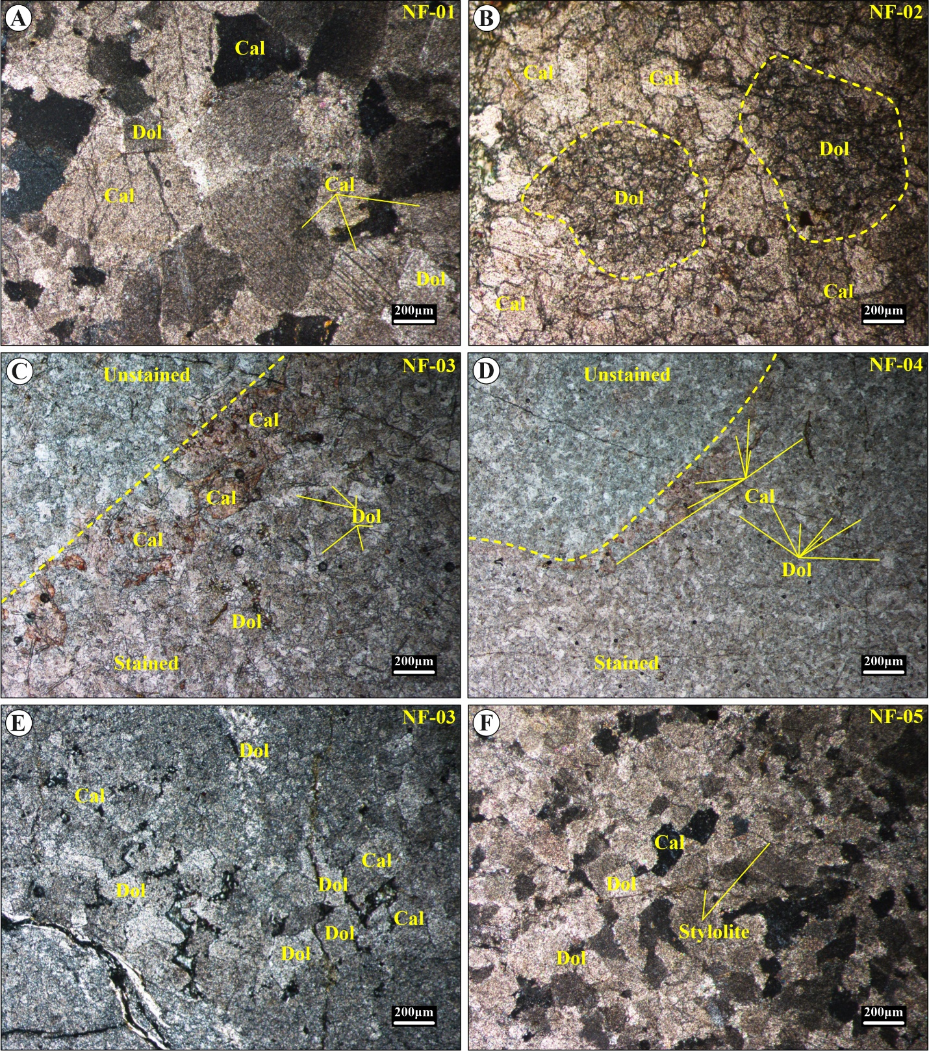

**Figure 1.** Photomicrographs of the studied Nowshera Formation, Maneri Section showing; **A)** interlocking crystalline textures between calcite (Cal) and dolomite (Dol) grains, XPL (NF-01); **B)** insets of large, rounded to subrounded detrital ferroan dolomite grain (D) in the upper reef breccia and fossil debris unit, PPL (NF-02); **C)** image showing stained (lower) and unstained (upper) portions that displays a more heterogeneous texture with calcite (Cal) and dolomite (Dol) grains of varying sizes (NF-03); **D)** Image showing stained/ unstained portions that shows a relatively more homogeneous texture with well-defined calcite (Cal) and dolomite (Dol) grains, PPL (NF-04). The crystalline structure is slightly more compact; **E)** Image showing a mixture of calcite (Cal) and dolomite (Dol) grains with irregular and dispersed distribution indicating limited recrystallization, PPL, (NF-03); **F)** Well preserved, fine-grained interlocking textures between calcite (Cal) and dolomite (Dol) crystals with observed stylolite, highlighting pressure dissolution and compaction features, XPL (NF-05).

**Table 5.** Fracture density of rocks measured in millimetre.

|  |  |  |  |  |  |
| --- | --- | --- | --- | --- | --- |
| FRACTURE DENSITY | | | | | |
| Rock Types | TEMPERATURE | | | | |
| 150°C | 300°C | 600°C | 800°C | 1000°C |
| DL | 86.673 | 171.09 | 324 | 435 | 677.93 |
| RY | 107.232 | 184.74 | 382.34 | 489.98 |  |
| GN | 80.32 | 170.29 | 284.35 | 361.46 | 555.84 |
| SST | 120.49 | 253.82 | 565.48 | 663.48 |  |
| LST | 117.27 | 240.97 | 403.22 |  |  |
| QZ | 93.18 | 179.92 | 348.6 | 483.55 | 684.36 |
| HGN | 115.67 | 202.42 | 395.19 | 581.54 | 841.79 |
| AM | 54.62 | 165.47 | 279.53 | 324.51 | 528.53 |
| GG | 53.01 | 163.86 | 218.48 | 308.44 | 403.22 |