Thermal degradation of diverse rock suites: Insights from fractures and physical and mechanical analysis

Abid Nawaz^{1*} , Muhammad Sajid^{2,3} , Waqas Ahmed¹ , Abdul Rahim Asif^{1,4}
¹ National Centre of Excellence in Geology, University of Peshawar, Peshawar 25120, Pakistan.
² Department of Geology, University of Peshawar, Peshawar, 25120, Pakistan.
³ Helmholtz-Zentrum Potsdam, Deutsches GeoForschungsZentrum (GFZ), Telegrafenberg, Potsdam, Germany.
⁴ Department. of Geology, Fata University, FR Kohat 26100, Pakistan.

Supplementary file

Table 1. Uniaxial Compressive Strength (UCS), Point Load, Ultrasonic Pulse Velocity (UPV), and Fracture Distribution Results for Rocks
Rock Types | Temperature Ranges (°C)
Rock Types | 25 | 150 | 300 | 600 | 800 | 1000
UCS (MPa)
SST | 47 | 37 | 32 | 12 | 5 | --
LST | 56 | 46 | 43 | 16 | -- | --
HGN | 71 | 60 | 58 | 26 | 16 | 8
RY | 86 | 74 | 73 | 35 | 22 | 11
QZ | 102 | 90 | 80 | 47 | 29 | 16
DL | 115 | 104 | 103 | 58 | 36 | 21
GN | 128 | 119 | 117 | 75 | 44 | 26
AM | 135 | 128 | 125 | 87 | 51 | 31
GG | 141 | 136 | 133 | 98 | 58 | 37
POINT LOAD INDEX
SST | 25 | 21 | 16 | 6 | 3 | ------
LST | 31 | 27 | 22 | 8 | -- | --
HGN | 38 | 34 | 29 | 18 | 9 | 4
RY | 42 | 38 | 34 | 23 | 12 | 6
QZ | 47 | 43 | 40 | 28 | 15 | 9
DL | 52 | 48 | 45 | 32 | 18 | 13
GN | 57 | 54 | 51 | 38 | 23 | 16
AM | 61 | 58 | 55 | 43 | 29 | 20
GG | 68 | 66 | 62 | 52 | 37 | 25
UPV (m/sec)
SST | 3256 | 2881 | 2470 | 1176 | 981 | --
LST | 3537 | 3157 | 2709 | 1792 | -- | --
HGN | 4206 | 3808 | 3351 | 2216 | 1508 | 636
RY | 4531 | 4124 | 3712 | 2473 | 1893 | 833
QZ | 4900 | 4505 | 4152 | 2870 | 2154 | 1025
DL | 5120 | 4743 | 4422 | 3156 | 2432 | 1195
GN | 5280 | 4929 | 4698 | 3573 | 2776 | 1698
AM | 5458 | 5165 | 4942 | 3914 | 3160 | 2209
GG | 5741 | 5525 | 5318 | 4518 | 3487 | 2606
FRACTURE DENSITY
SST | -- | 0.75 | 1.58 | 3.52 | 4.13 | 6
LST | -- | 0.73 | 1.5 | 2.51 | -- | --
HGN | -- | 0.72 | 1.26 | 2.46 | 3.62 | 5.24
RY | -- | 0.67 | 1.15 | 2.38 | 3.05 | --
QZ | -- | 0.58 | 1.12 | 2.17 | 3.01 | 4.26
DL | -- | 0.54 | 1.07 | 2.01 | 2.71 | 4.22
GN | -- | 0.5 | 1.06 | 1.77 | 2.25 | 3.46
AM | -- | 0.34 | 1.03 | 1.74 | 2.02 | 3.29
GG | -- | 0.33 | 1.02 | 1.36 | 1.92 | 2.51

Table 2. Results of Porosity, Water Absorption and Specific Gravity of studied rocks
ROCK TYPES | Temperature Ranges (°C)
ROCK TYPES | 25 | 150 | 300 | 600 | 800 | 1000
POROSITY (%)
SST | 2.60 | 2.92 | 3.04 | 8.98 | 13.31 | --
LST | 2.01 | 2.18 | 2.28 | 6.01 | -- | --
HGN | 1.68 | 1.77 | 1.85 | 3.48 | 4.88 | 6.74
RY | 1.17 | 1.23 | 1.28 | 1.81 | 2.42 | 3.28
QZ | 0.97 | 1.01 | 1.05 | 1.38 | 1.74 | 2.39
DL | 0.61 | 0.63 | 0.66 | 0.83 | 0.96 | 1.26
GN | 0.56 | 0.58 | 0.6 | 0.72 | 0.80 | 1.10
AM | 0.37 | 0.38 | 0.39 | 0.46 | 0.50 | 0.63
GG | 0.30 | 0.31 | 0.31 | 0.36 | 0.39 | 0.48
WATER ABSORPTION (%)
SST | 1.67 | 1.87 | 2.02 | 5.79 | 8.85 | --
LST | 1.29 | 1.41 | 1.51 | 3.95 | -- | --
HGN | 0.51 | 0.55 | 0.57 | 0.92 | 1.15 | 1.82
RY | 0.43 | 0.46 | 0.47 | 0.70 | 0.83 | 1.22
QZ | 0.36 | 0.38 | 0.39 | 0.50 | 0.61 | 0.85
DL | 0.21 | 0.218 | 0.23 | 0.28 | 0.32 | 0.43
GN | 0.19 | 0.195 | 0.20 | 0.25 | 0.27 | 0.37
AM | 0.14 | 0.143 | 0.15 | 0.17 | 0.19 | 0.24
GG | 0.11 | 0.112 | 0.12 | 0.13 | 0.14 | 0.17
SPECIFIC GRAVITY (gm/cc)
LST | 2.69 | 2.66 | 2.63 | 2.48 | -- | --
HGN | 2.75 | 2.72 | 2.70 | 2.52 | 2.39 | 1.98
RY | 2.80 | 2.78 | 2.75 | 2.60 | 2.47 | 2.12
QZ | 2.86 | 2.84 | 2.82 | 2.67 | 2.57 | 2.21
DL | 3.01 | 2.99 | 2.97 | 2.84 | 2.73 | 2.35
GN | 3.09 | 3.07 | 3.06 | 2.93 | 2.82 | 2.47
AM | 3.14 | 3.13 | 3.11 | 2.99 | 2.89 | 2.59
GG | 3.21 | 3.20 | 3.19 | 3.07 | 2.98 | 2.70

Table 3. Thermal Damage (DT) Values Calculated Using Uniaxial Compressive Strength (UCS), Ultrasonic Pulse Velocity (UPV), and Point Load (PL) Results
Rock Types | Temperature Ranges (°C)
Rock Types | 150 | 300 | 600 | 800 | 1000
DT (UCS)
DL | 0.07 | 0.14 | 0.38 | 0.53 | 0.77
RY | 0.09 | 0.18 | 0.45 | 0.58 | 0.82
GN | 0.07 | 0.11 | 0.32 | 0.47 | 0.68
SST | 0.12 | 0.24 | 0.64 | 0.70
LST | 0.11 | 0.23 | 0.49
QZ | 0.08 | 0.15 | 0.41 | 0.56 | 0.79
HGN | 0.09 | 0.20 | 0.47 | 0.64 | 0.85
AM | 0.05 | 0.09 | 0.28 | 0.42 | 0.60
GG | 0.04 | 0.07 | 0.21 | 0.39 | 0.55
DT (PL)
DL | 0.08 | 0.13 | 0.38 | 0.65 | 0.75
RY | 0.10 | 0.19 | 0.45 | 0.71 | 0.86
GN | 0.05 | 0.11 | 0.33 | 0.60 | 0.72
SST | 0.16 | 0.36 | 0.76 | 0.88
LST | 0.13 | 0.29 | 0.74
QZ | 0.09 | 0.15 | 0.40 | 0.68 | 0.81
HGN | 0.11 | 0.24 | 0.53 | 0.76 | 0.89
AM | 0.05 | 0.10 | 0.30 | 0.52 | 0.67
GG | 0.03 | 0.09 | 0.24 | 0.46 | 0.63
DT (UPV)
DL | 0.07 | 0.14 | 0.38 | 0.53 | 0.77
RY | 0.09 | 0.18 | 0.45 | 0.58 | 0.82
GN | 0.07 | 0.11 | 0.32 | 0.47 | 0.68
SST | 0.12 | 0.24 | 0.64 | 0.70
LST | 0.11 | 0.23 | 0.49
QZ | 0.08 | 0.15 | 0.41 | 0.56 | 0.79
HGN | 0.09 | 0.20 | 0.47 | 0.64 | 0.85
AM | 0.05 | 0.09 | 0.28 | 0.42 | 0.60
GG | 0.04 | 0.07 | 0.21 | 0.39 | 0.55

Table 4. Showing the modal mineralogy of the studied Nowshera Formation
Rock Name | Sample no. | Calcite | Dolomite/ferroan dolomite | Silica | Clay minerals | Porosity | Dunham's Classification (1962)
Nowshera Formation | NF-01 | 54 | 39 | 2 | 3 | 2 | Dolomitic limestone
Nowshera Formation | NF-02 | 58 | 40 | 1 | - | 1 | Dolomitic limestone
Nowshera Formation | NF-03 | 57 | 38 | 2 | 1 | 2 | Dolomitic limestone
Nowshera Formation | NF-04 | 55 | 40 | 1 | 2 | 1 | Dolomitic limestone
Nowshera Formation | NF-05 | 56 | 41 | 0 | 1 | 2 | Dolomitic limestone

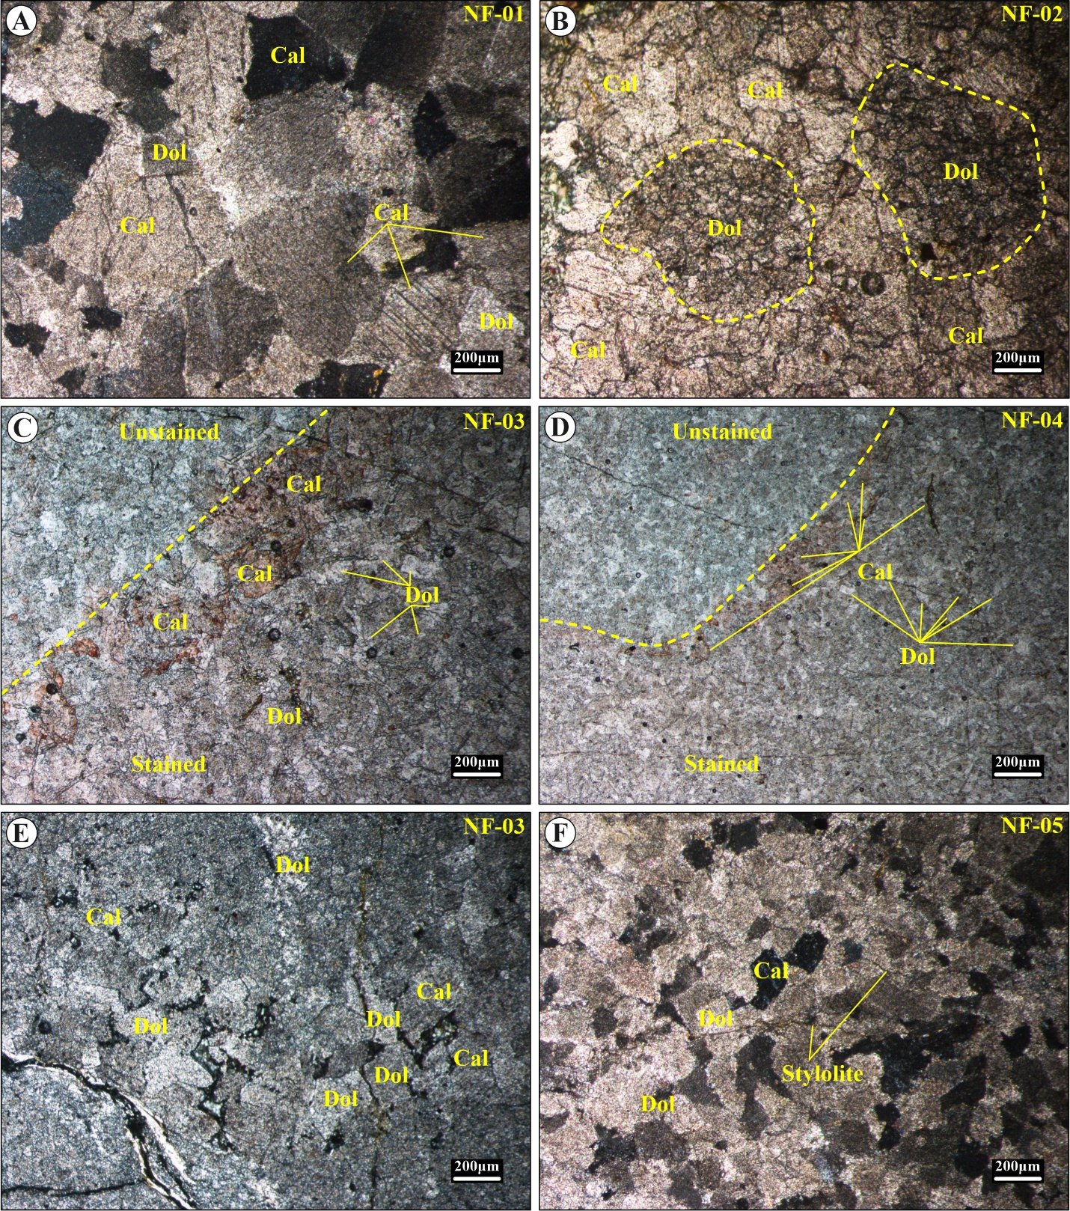
Figure 1. Photomicrographs of the studied Nowshera Formation, Maneri Section showing; A) interlocking crystalline textures between calcite (Cal) and dolomite (Dol) grains, XPL (NF-01); B) insets of large, rounded to subrounded detrital ferroan dolomite grain (D) in the upper reef breccia and fossil debris unit, PPL (NF-02); C) image showing stained (lower) and unstained (upper) portions that displays a more heterogeneous texture with calcite (Cal) and dolomite (Dol) grains of varying sizes (NF-03); D) Image showing stained/ unstained portions that shows a relatively more homogeneous texture with well-defined calcite (Cal) and dolomite (Dol) grains, PPL (NF-04). The crystalline structure is slightly more compact; E) Image showing a mixture of calcite (Cal) and dolomite (Dol) grains with irregular and dispersed distribution indicating limited recrystallization, PPL, (NF-03); F) Well preserved, fine-grained interlocking textures between calcite (Cal) and dolomite (Dol) crystals with observed stylolite, highlighting pressure dissolution and compaction features, XPL (NF-05).

Table 5. Fracture density of rocks measured in millimetre.
FRACTURE DENSITY
Rock Types | TEMPERATURE
Rock Types | 150°C | 300°C | 600°C | 800°C | 1000°C
DL | 86.673 | 171.09 | 324 | 435 | 677.93
RY | 107.232 | 184.74 | 382.34 | 489.98
GN | 80.32 | 170.29 | 284.35 | 361.46 | 555.84
SST | 120.49 | 253.82 | 565.48 | 663.48
LST | 117.27 | 240.97 | 403.22
QZ | 93.18 | 179.92 | 348.6 | 483.55 | 684.36
HGN | 115.67 | 202.42 | 395.19 | 581.54 | 841.79
AM | 54.62 | 165.47 | 279.53 | 324.51 | 528.53
GG | 53.01 | 163.86 | 218.48 | 308.44 | 403.22

